Twin Primes and Factorization

Shaimaa said soltan1

1 Computer Engineer, Toronto, Canada

Correspondence: Shaimaa Soltan, 3050 Constitution Blvd, Mississauga, ON., L4Y 3X1, Canada. Tel: 1-647-801-6063 E-mail: shaimaasultan@hotmail.com

---------------------------------------------------------------------------------------------------------------------------------

**Suggested Reviewers** (Optional)

Please suggest 3-5 reviewers for this article. We may select reviewers from the list below in case we have no appropriate reviewers for this topic.

|  |  |
| --- | --- |
| Name: | E-mail: |
| Affiliation: | |

|  |  |
| --- | --- |
| Name: | E-mail: |
| Affiliation: | |

|  |  |
| --- | --- |
| Name: | E-mail: |
| Affiliation: | |

|  |  |
| --- | --- |
| Name: | E-mail: |
| Affiliation: | |

|  |  |
| --- | --- |
| Name: | E-mail: |
| Affiliation: | |

Twin Primes and Factorization

**Abstract**

This paper presents a new algorithm to find Twin primes in between two numbers in an execution time not related exponentially to the size of the number. The size of the number is how many digits in the number. Because this algorithm can run partially on range (from number to number) it can be executed in nonexponential time related to the number size.

**Keywords:** Twin Primes

**1. Introduction**

Any prime number is only divisible by its own and by one only. And Twin Primes are prime numbers separated by only one step. In this algorithm we are going to use a reverse way we are going to use the twin primes to get the primes and not the opposite.

We found that the primes that are not part of any twin primes like number 23, are factors for other composite primes and not part of any other twin prime pairs. They are part of pairs with perfect square numbers like These set of odd numbers of pairs [23,25] and like [47,49] and [119,121].

23, 47 ,119 are not in any twin pair but they are used as a factor in other odd pairs. These prime numbers are used as bind prime numbers and odd numbers that are not primes.

Each time we increase the number of twin primes list we used to initiate our search list reduces the execution time of the algorithm. As this algorithm have only one simple loop to get the initial list using modulus operation and another two nested loops based on this initial list. The other benefit of this algorithm is that you can get the primes and their twin pairs in-between two numbers.

For example, 23 is a factor for these pairs. Starting from 1 and up until 5000.

[851, 853] 23

[941, 943] 23

[989, 991] 23

[1217, 1219] 23

[1541, 1543] 23

[1907, 1909] 23

[2369, 2371] 23

[2459, 2461] 23

[2921, 2923] 23

[3011, 3013] 23

[3149, 3151] 23

[3611, 3613] 23

[3977, 3979] 23

[4391, 4393] 23

[4439, 4441] 23

This is why in this algorithm use the twin primes to get the primes and not the other way around.

This algorithm is simply using two main conditions.

1. Not Odd number and perfect square at the same time.
2. Odd number that are not divisible by an initial limited set of elementary prime number

We are going to get a list of all pairs of odd numbers that have modulus = 0 for this number of prime twins list {[2,3], [5,7], [11,13], [17 ,19], [29, 31]} as a beginning of an initial list of odd numbers.

Preparing a list of twin primes using these two rules will reduce the number of calculations. As we have for variations for these pairs (1 means prime, 0 means odd but not prime) [0, 0], [0,1], [1,0], [1,1].

And this is the state that we start with as we know those initial pairs already and they are easy to apply to any big range of numbers list {[2,3], [5,7], [11,13], [17 ,19], [29, 31]}.

Applying modulus check on all numbers in-between two numbers will reduce the numbers of odd pairs dramatically because it will eliminate pairs from the two other cases [0,0], [0,1] and [1,0].

And using the first rule {Not odd number and perfect square at the same time} will reduce the number of pairs for the case [0,0], [0,1] [1,0] as this rule will eliminate the numbers like 23 in the case of the pair [23 ,25] and like [47,49] and [119 , 121] that is used as bind between prime numbers and twin prime pairs.

We do not loop on all numbers in our two nested loop we only loop on 4 * the difference between the two numbers to get the prime pairs.

Example (1): - List of prime pairs in between these two numbers

start_from = 897485600000000000

end_at = 897485600000000999

This step gives us a list of prime numbers of factors for the odd numbers in-between.

This is the list of pairs that fall into state [0,1] or [1,0] where one of the odd numbers is composite prime.

And this is the list of odd pairs that fall in the case [0,0], [1,0], [0.1] pairs that have one prime or no primes at all but no composite primes.

Example (2): - List of prime pairs in between these two numbers

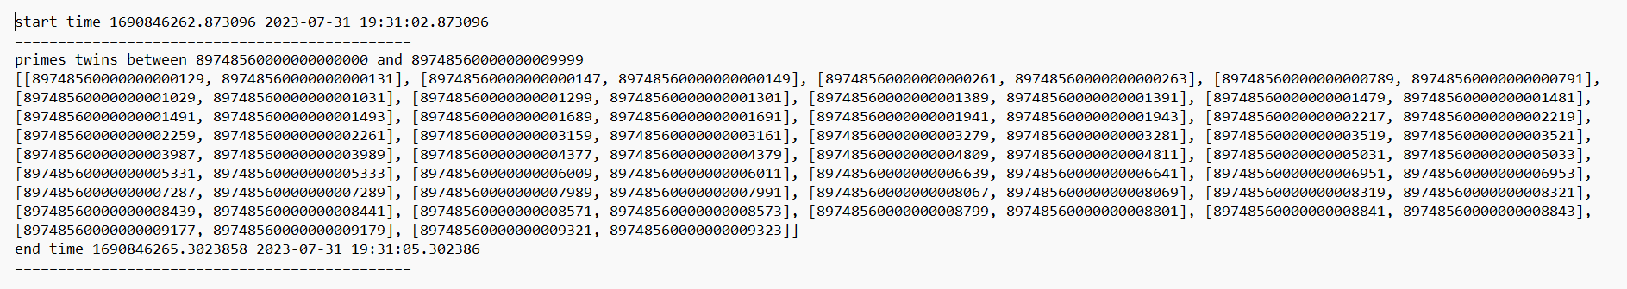It took almost 3 seconds.

This step gives us a list of prime numbers of factors for the odd numbers in-between.

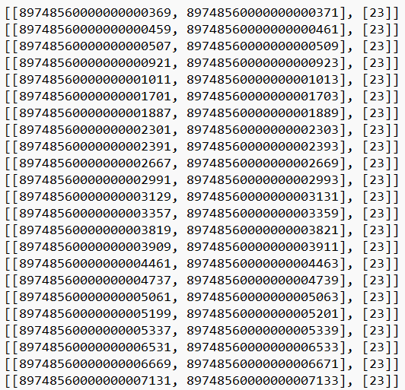This is the list of pairs that fall into state [0,1] or [1,0] where one of the odd numbers is composite prime.

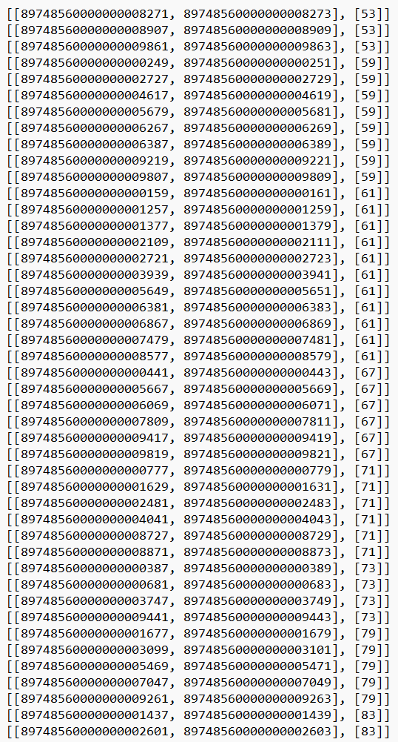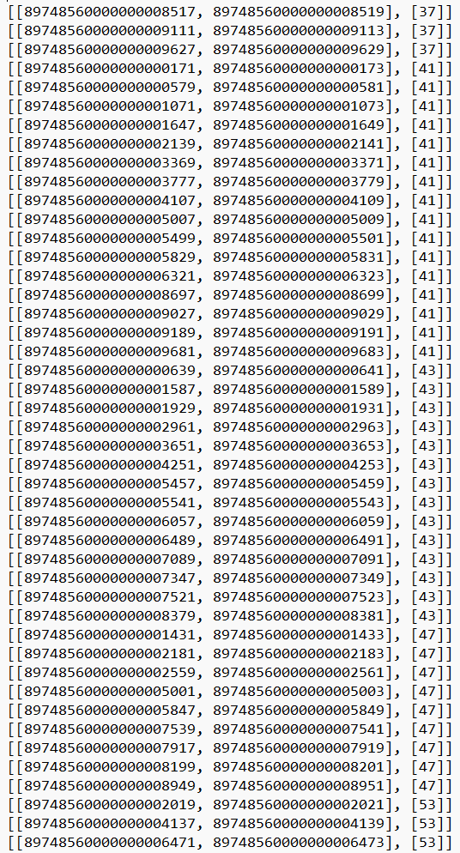

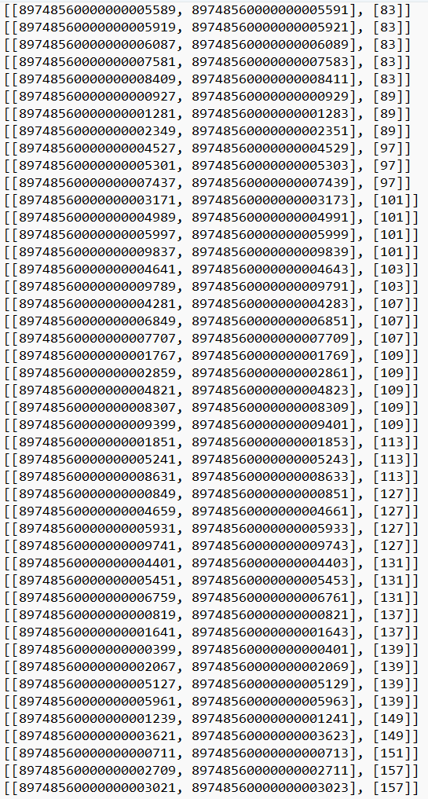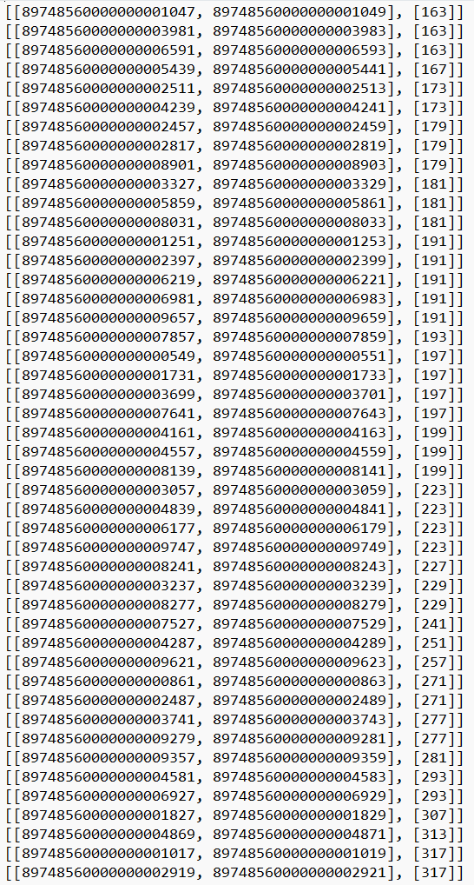

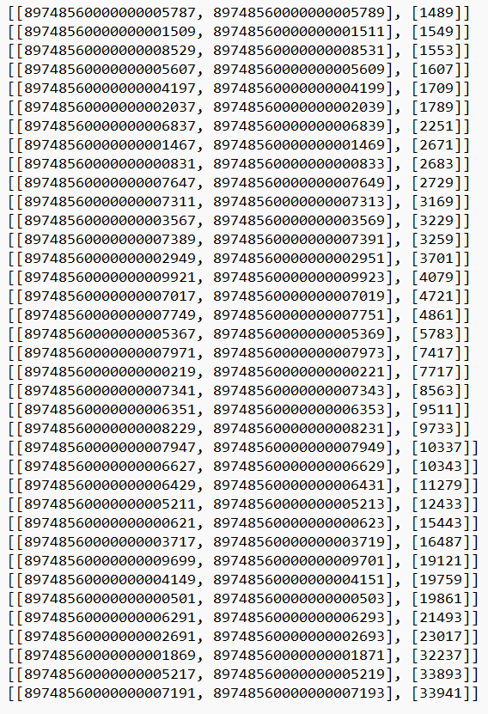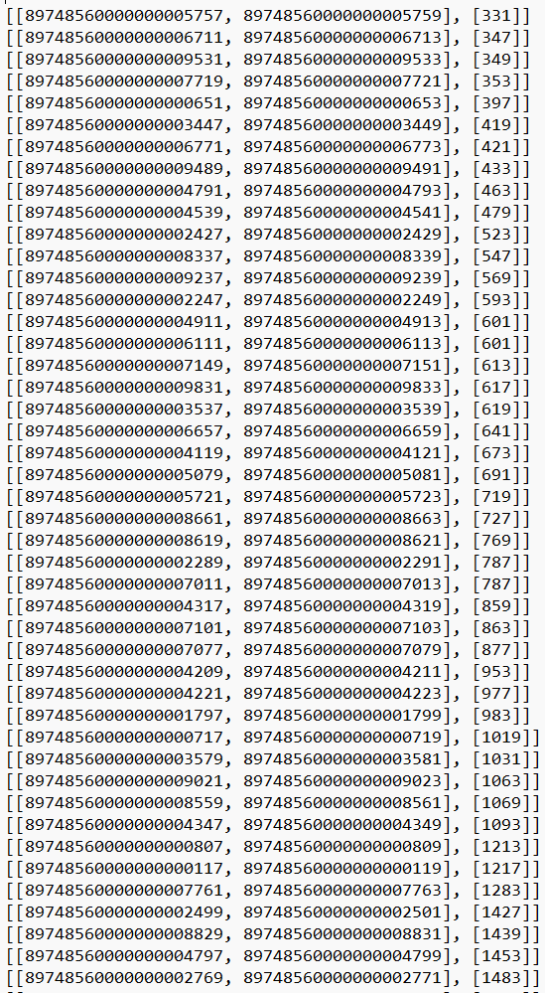

And this is the list of odd pairs that fall in the case [0,0], [1,0], [0.1] pairs that have one prime or no primes at all but no composite primes.

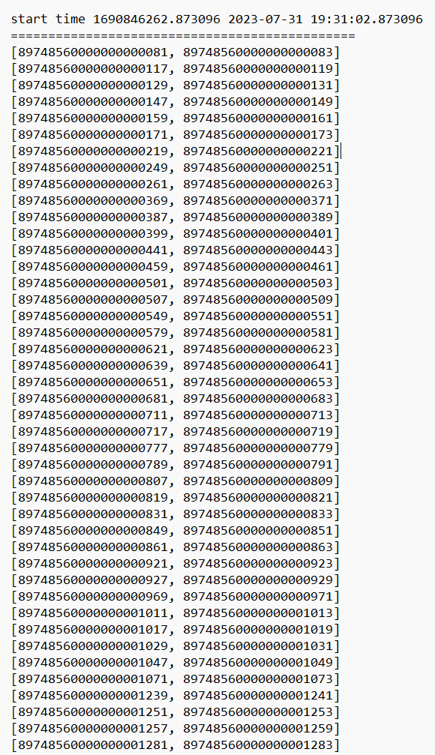

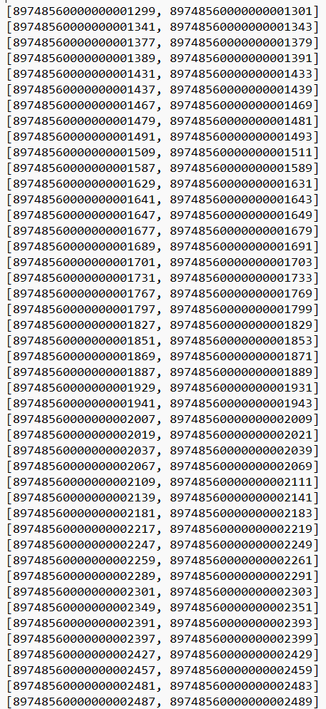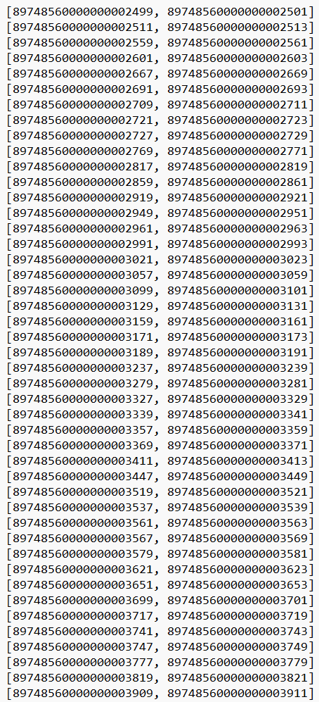

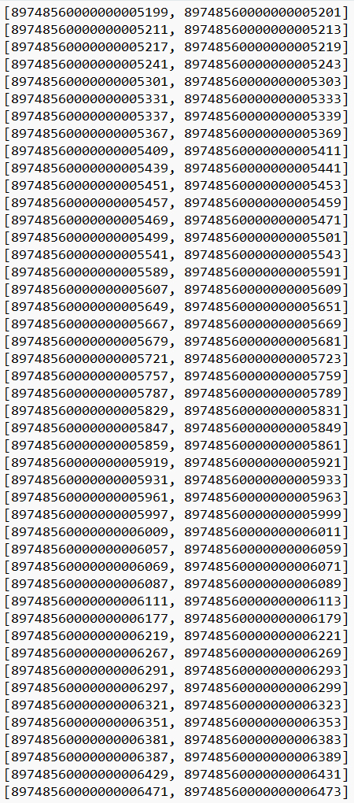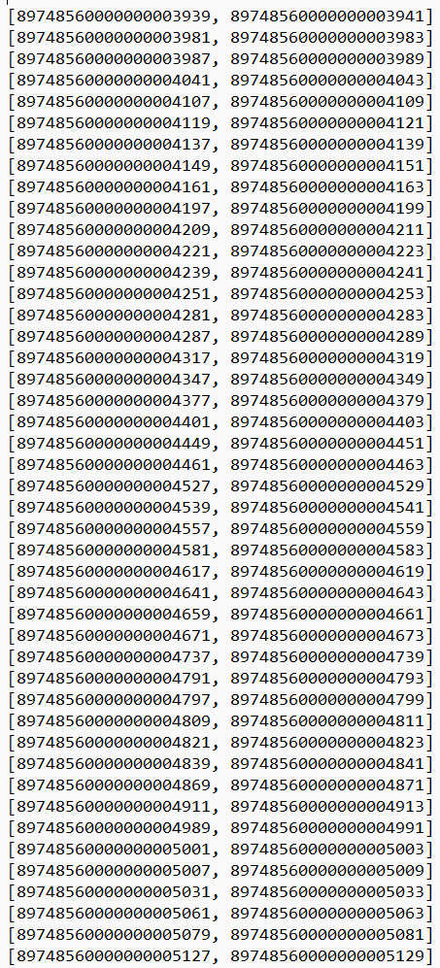

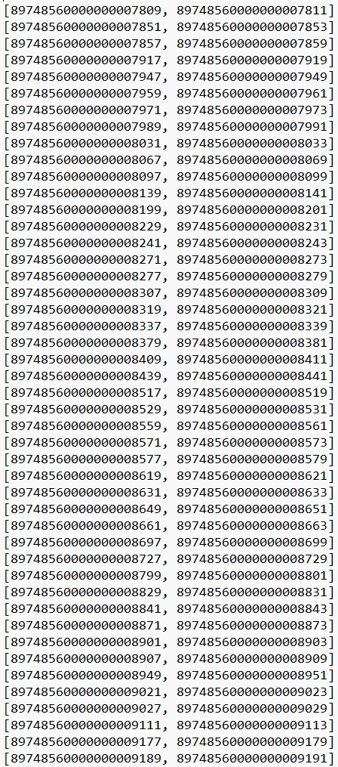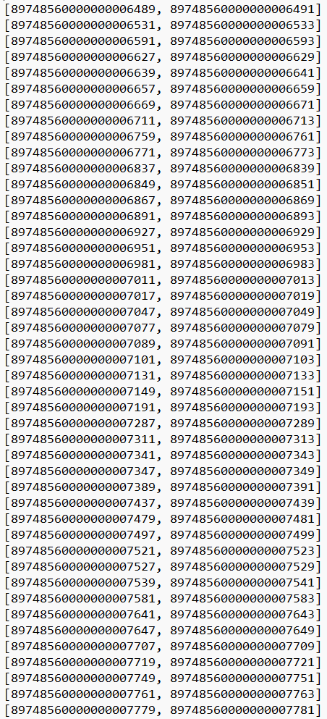

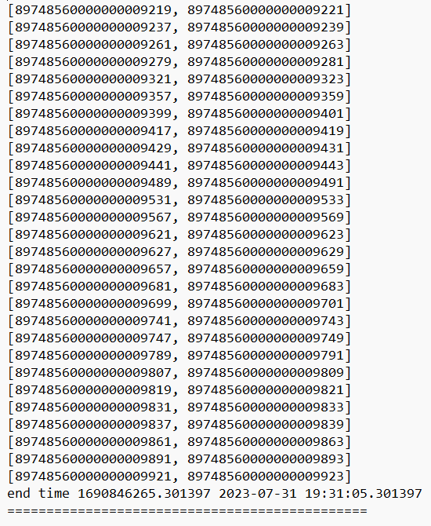

Example (3): -  in 7 seconds

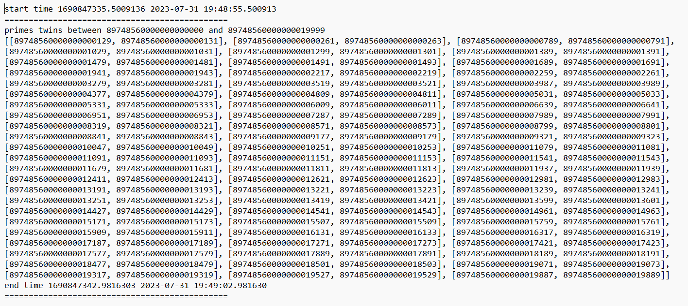

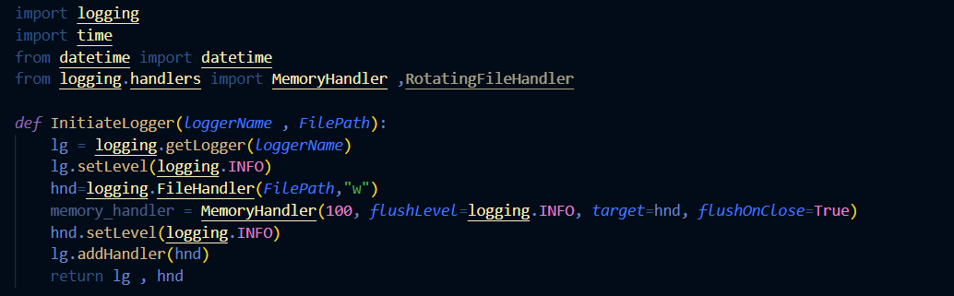

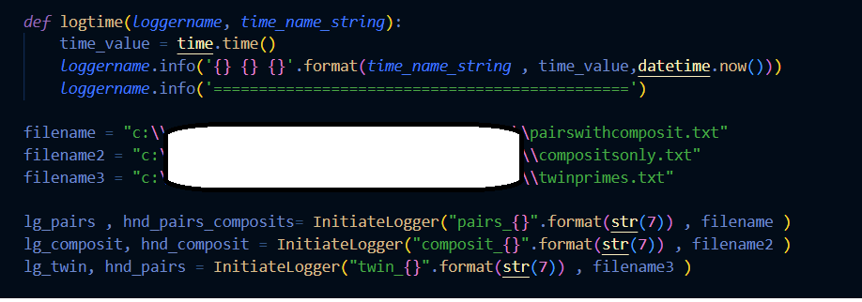

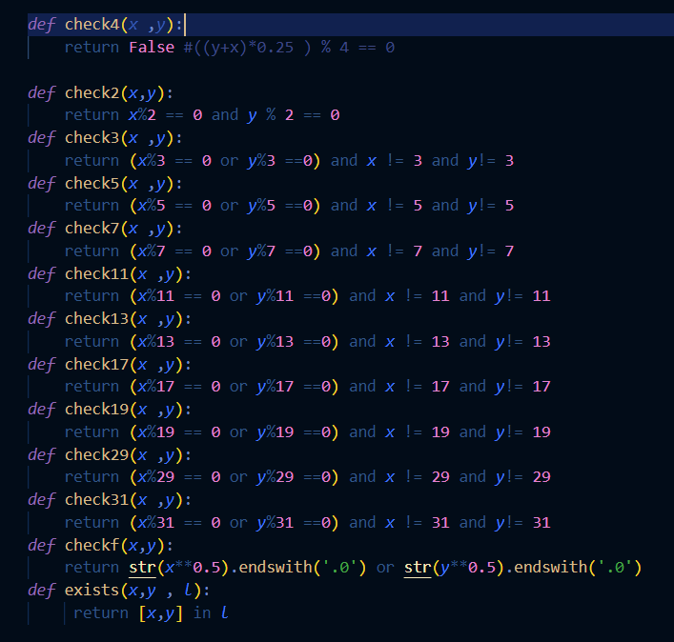

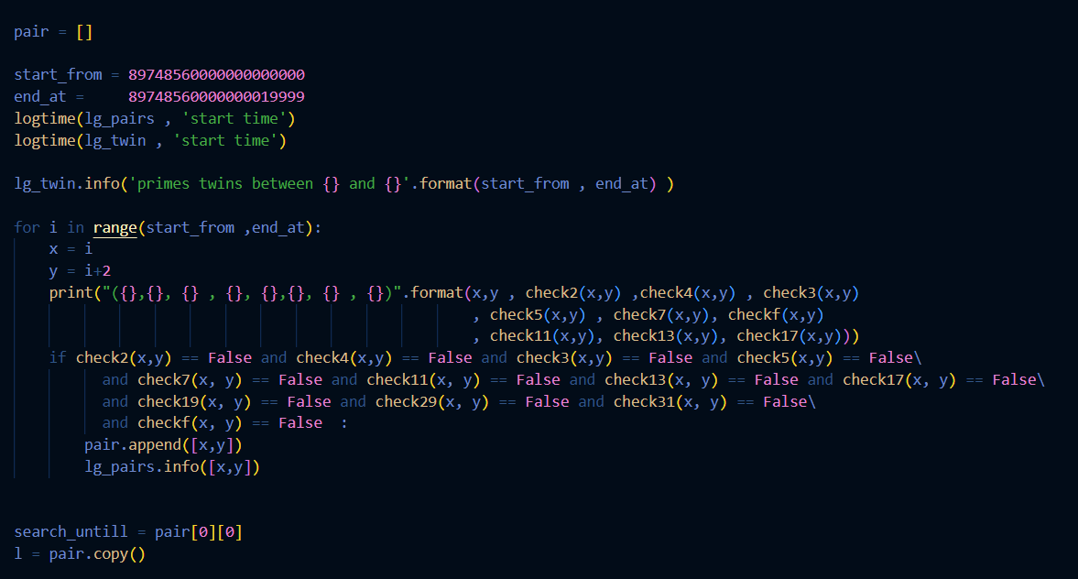

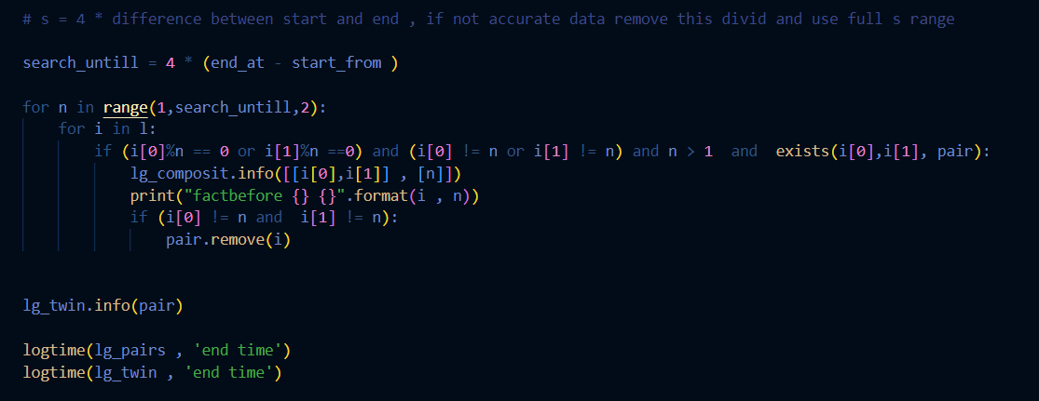

**Conclusion**

In This paper I am introducing a new algorithm that gets twin primes and prime numbers in between two numbers in a time not related exponentially to the size of the number.

I showed that, we can have a very good execution time to get prime factors for all prime numbers in between two numbers and this execution time is not related exponentially with the size of the number.

By doing modulus on odd numbers of pairs using only the list of twin primes I was able to get twin primes and prime factor for the numbers in between two numbers in an execution time not exponentially in relation to the size of the numbers.

**References**

[1] Polymath, D.H.J. (2014). "Variants of the Selberg sieve, and bounded intervals containing many primes". Research in the Mathematical Sciences. 1. artc. 12, 83. [arXiv](https://en.wikipedia.org/wiki/ArXiv_(identifier)):[1407.4897](https://arxiv.org/abs/1407.4897). [doi](https://en.wikipedia.org/wiki/Doi_(identifier)):[10.1186/s40687-014-0012-7](https://doi.org/10.1186%2Fs40687-014-0012-7). [MR](https://en.wikipedia.org/wiki/MR_(identifier)) [3373710](https://mathscinet.ams.org/mathscinet-getitem?mr=3373710). https://doi.org/10.1186%2Fs40687-014-0012-7

 [2] McKee, Maggie (14 May 2013). ["First proof that infinitely many prime numbers come in pairs"](http://www.nature.com/news/first-proof-that-infinitely-many-prime-numbers-come-in-pairs-1.12989). [Nature](https://en.wikipedia.org/wiki/Nature_(journal)). [doi](https://en.wikipedia.org/wiki/Doi_(identifier)):[10.1038/nature.2013.12989](https://doi.org/10.1038%2Fnature.2013.12989). [ISSN](https://en.wikipedia.org/wiki/ISSN_(identifier)) [0028-0836](https://www.worldcat.org/issn/0028-0836). https://doi.org/10.1038%2Fnature.2013.12989

[[3]](https://en.wikipedia.org/wiki/Twin_prime#cite_ref-10) [Zhang, Yitang](https://en.wikipedia.org/wiki/Yitang_Zhang) (2014). ["Bounded gaps between primes"](https://doi.org/10.4007%2Fannals.2014.179.3.7). [Annals of Mathematics](https://en.wikipedia.org/wiki/Annals_of_Mathematics). 179 (3): 1121–1174. [doi](https://en.wikipedia.org/wiki/Doi_(identifier)):[10.4007/annals.2014.179.3.7](https://doi.org/10.4007%2Fannals.2014.179.3.7). [MR](https://en.wikipedia.org/wiki/MR_(identifier)) [3171761](https://mathscinet.ams.org/mathscinet-getitem?mr=3171761). https://doi.org/10.4007%2Fannals.2014.179.3.7